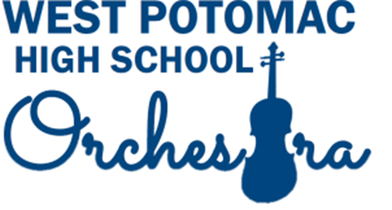

Sponsor our Orchestra! Become an Orchestra Patron
We need your Support! These funds help supply:
music, instruments, guest conductors, sectional workshops, solo & ensemble festival fees, and many other expenses required to maintain our quality program.

Levels of Sponsorship:
Symphony...........................................................................$500+
Concerto....................................................................$250-499
Sonata..........................................................................$150-249
Whole Note.................................................................$100-149
Half Note........................................................................$50-99
Quarter Note.................................................................$25-49
Eighth Note...............................................................under $25
Any amount will be greatly appreciated! Thank you!

NAME: _____________________________________________________

ADDRESS:___________________________________________________

CONTRIBUTION AMOUNT: ____________________
If you want any of the amount directed specifically to scholarships or the music commission, please note which and how much: ___________________________________

We recognize patrons in the concert program; please list your name as it should appear:
________________________________________________________________________

• Contributions payable to WPHS Orchestra Boosters •
Attention: Alicia Day Javkhlan, WPHS, 6500 Quander Road, Alexandria, VA 22307

OR pay via this link: https://checkout.square.site/pay/d9ac16d6248149b88db90c725434d11e

*Contributions are tax-deductible: EIN # 26-3720138.

